Slide 1: Title Slide
Title: Information Systems Strategy and IT Governance in LOLC Finance PLC
Group Members:
- G.S. Chamika – ICT/20/818
- Y.N.S. Dissanayake – ICT/20/837
- B.G.D.T.T. Jeerasinghe – ICT/20/863

Slide 2: Table of Contents
- Introduction
- Strategic Plan
- IS/IT Strategy Plan
- IT Governance Maturity Analysis
- Steps for IT Strategic Alignment
- Implementing IT Governance
- Conclusion

Slide 3: Introduction
LOLC Holdings operates in several industries, including financing, manufacturing, insurance, leisure, and agriculture. our study, we focus on LOLC Finance PLC, to explore how IS/IT plans are integrated to support its operations.
About LOLC Finance PLC:
LOLC Finance PLC is a non-banking financial company based in Sri Lanka. The company was founded in 2001, and it is the financial arm of LOLC Group.
The company provides financial services like leasing, loans, microfinance, and digital solutions.

Slide 4: Strategic Plan
Vision: Inclusive financial services exceeding customer expectations.
Mission: Setting industry standards in non-banking financial services.
Goals and Objectives:
- Facilitate SME growth.
- Embed sustainability and ESG principles.
- Leverage technology for scalable solutions.
- Expand and diversify offerings globally.

Slide 6: IS/IT Strategy Plan
Specific IT related Goals and Objectives:
- The primary IT-related goal is to provide uninterrupted banking experience through the online banking platforms.
- Developing a leading online payment mobile application and being a leading digital financial service provider in Sri Lanka.
- Implement industry-standard security protocols.
- Providing 24-hour real-time digital financial experience without systems down.
Main Components:
- Core Banking System: FusionX.
- Digital Channels: iPay app.
- Infrastructure: Cloud and data center management.
- Data Analytics: Real-time KPI monitoring.

Slide 7: IT Governance Maturity Analysis
Luftman’s SAM Model:
We used Luftman’s Strategic Alignment Maturity (SAM) Model assesses how effectively an organization aligns its IT and business strategies.
- Communication: Centralized policies and user training.
- Value Measurement: KPIs linked to IT investments.
- Governance: Compliance with regulations and audits.
- Partnership: IT viewed as a strategic partner.
- Scope: Integrated systems (FusionX, iPay).
- Skills: Continuous upskilling and collaboration.

Slide 8: IT Governance Maturity Analysis Cont.
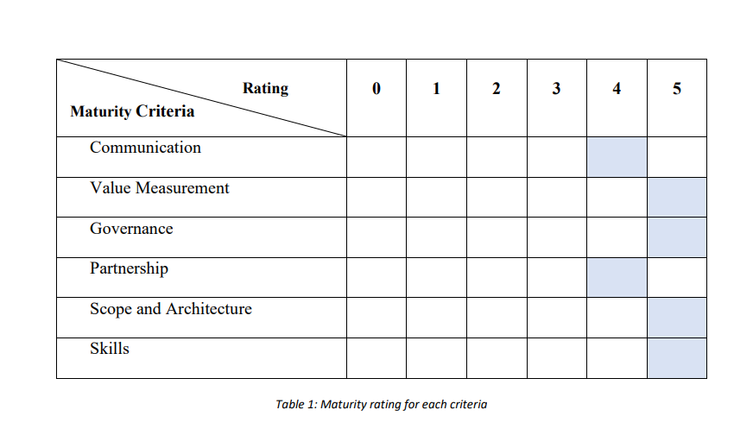
Based on the company interview insights and the findings of the SAMM ratings, we have chosen LOLC Finance’s IT governance maturity appears to be around Level 5 (Optimized) with some aspects trending forward to Level 4.

Slide 9: Steps for IT Strategic Alignment
Integrating ICT investments with corporate Strategy:
- Align ICT with corporate strategy.
- Invest in partnerships and alliances.
- Budget for innovation and security.
- Leverage global tech providers (e.g., Microsoft, Oracle).
Business Opportunities for Growth:
- Digital platforms (iPay).
- Geographic expansion (Cambodia, Myanmar, Nigeria).
- Flexible financial solutions via cloud infrastructure.
Cost-effective and flexible technology infrastructure for the future:
- Cloud services
- Network security and cybersecurity

Slide 10: Implementing IT Governance
LOLC Finance PLC is a financial institution therefore, COBIT framework is typically the most suitable and comprehensive IT Governance.
Steps:
- Stakeholders buy-in and gap analysis.
- Design governance structures.
- Implement processes and controls.
- Conduct training and awareness.
- Monitor and review for continuous improvement.

Slide 11: Implementing IT Governance Cont.
The use of ITG frameworks in similar organizations:
- Commercial Credit & Finance PLC: Core banking solutions.
- Dialog Finance PLC: Cybersecurity and mobile banking apps.
- Softlogic Finance PLC: Workflow automation and IT governance.

Slide 12: Conclusion
LOLC Finance operates in a competitive financial market and uses technology, strategic planning, and innovation to stay ahead. Its IT governance is strong but could improve further. By adopting a framework like COBIT, the company can better manage risks, use resources efficiently, and align IT with business goals. Clear processes, ongoing training, and continuous improvements will help LOLC Finance grow and provide value to its stakeholders locally and globally.

Slide 13: Thanks

